HIPAA

Acknowledgement of Receipt of Notice of Privacy Policy

I understand that under the Health Insurance Portability & Accountability Act of 1996 (HIPAA) I have certain rights to privacy regarding my protected health information. I understand that this information can and will be used to:

• Conduct, plan, and direct my treatment and follow-up among the multiple healthcare providers who may be involved in that treatment directly and indirectly.
• Obtain payment from third party payers.
• Conduct normal healthcare operations such as quality assessments and dentist/physician certifications.

I acknowledge that I have received notice of the availability of your Notice of Privacy Practices containing a more complete description of the uses and disclosures of my health information. I understand that this office has the right to change its Notice of Privacy Practices from time to time and that I may contact this office at any time at the address above to obtain a current copy of the Notice of Privacy Practices.

I understand that I may request in writing that you restrict how my private information is used or disclosed to carry out treatment, payment, or healthcare operations. I also understand that you are not required to agree to my requested restrictions, but if you do agree then you are bound to abide by such restrictions.

Patient's Name: ______________________________ Date: ___________________________

Signature: ______________________________ Relationship: _________________________
(Patient or Parent/Legal Guardian) (If Parent or Legal Guardian)

_

Office Use Only

I attempted to obtain the patients signature in acknowledgement of having received notice of the availability of Privacy Policies of this office, but was unable to do so as documented below:

Date: __________ Initials: ______ Reason: _________________________________________

Dental Appointment Agreement

Our goal at Apple Seeds Pediatric Dentistry is to help our patients achieve and maintain good oral health for a lifetime. In order to reach this goal it is important for patients to make every effort to keep their scheduled dental appointments. Broken appointments also result in unproductive time that our doctors or hygienists could have used to treat other patients who are awaiting an appointment.

Broken Appointments

Our dental team understands that sometimes situations arise that require you to reschedule or cancel an appointment. However; if you miss or cancel your appointment within 24 hours of the scheduled appointment it is considered a Broken Appointment and a fee of $35 will apply.

You may schedule another appointment at any time; however the Broken Appointment fee will be due at the time of the rescheduled appointment as well as any patient portion due that day.

If three Broken Appointments occur within a two year period, a non-refundable deposit in the amount of $100 will be required upfront before scheduling appointments. After completing three consecutive appointments the $100 deposit will no longer be required.

Any patient or family with a long term history of Broken Appointments may be dismissed from the practice at the discretion of the Practice Manager and affiliated doctor(s).

I understand the Dental Appointment Agreement and agree to follow the terms of the Broken Appointment Policy.

___________________________________________________________________
Patient Name (please print) Date

___________________________________________________________________
Patient or Guardian Signature

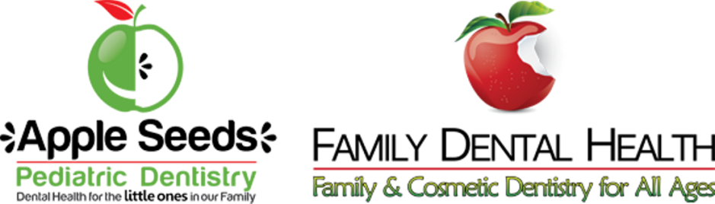

NOTICE OF PRIVACY PRACTICES
This Notice Describes How Dental/Medical Information About You May be-Used
and Disclosed and How You Can Get Access to This Information: Please Review It
Carefully.

The Health Insurance Portability & Accountability Act of 1996 (HIPAA) is a federal program requiring all medical records and other individually identifiable health information used or disclosed by us in any form, whether electronically, written, or oral be properly kept confidential. This Act gives you, as a patient, significant new rights to understand and control how your personal health information is used.
HIPAA provides penalties for covered entities that misuse your health information.

As required by this Act we have prepared this explanation of how we are required to maintain the privacy of your health information and how we may use and disclose your health information. We may use and disclose your dental/medical information only for each of the following purposes: treatment, payment, and health ca\e operations.

• Treatment means providing, coordinating or managing health care and related services by one or more health care providers. An example of this would include an oral examination or a procedure performed on a tooth.

• Payment means such activities as obtaining reimbursement for services, confirming coverage, collection activities and utilization review. An example would be submitting a claim form on your behalf to your insurance company.

• Health care operations include the business aspects of running our practice, such as conducting quality assessment and improvement activities, auditing functions, cost-management analysis and customer service. An example would be accounts receivable or overhead analysis with our accountants.

We may also create and distribute de-identified health information by removing all references to individually identifiable information. An example would be statistical studies relating to the frequency of certain procedures in the population. We may contact you to provide appointment reminders or information about treatment or other health-related benefits and services that may be of value to you.

Any other uses and disclosures will be made only with your written authorization. You may revoke such authorization in writing also, and we are obligated to honor that request, except to the extent that we have already taken actions relying on your prior authorization.
You have the following rights with respect to your protected health information, which you can exercise by presenting a written request to Apple Seeds Pediatric Dentistry.

• The right to request restrictions on certain uses and disclosures of protected health information, including those related to disclosures to family members, other relatives, close personal friends, or any other person identified by you. We are not, however, required by this Act to agree to a requested restriction, but if we do agree, we must abide by that agreement, unless and until you release us in writing.
• The right to reasonable requests to receive confidential communications of protected health information from us by alternative means or at alternative locations.
• The right to inspect and copy your protected health information.
• The right to amend your protected health information, except that official treatment records (records denoting dates and particulars of care) may not be altered. These are sometimes subpoenaed in legal proceedings.
• The right to receive an accounting of disclosures of protected health information.
• The right to obtain a paper copy of this notice at your first or any subsequent service delivery date after April 14, 2003.

This notice is effective as of April 14, 2003 and will remain as written until such time as we may determine a need to change its terms. A current copy of this notice will be kept in a folder in our reception area and will be marked for easy identification. You may request an updated copy for personal use at any time.

You have recourse if you feel that your privacy protections have been violated. You may file a formal, written complaint with us at our official address (see below) or with the Department of Health & Human Services, Office of Civil Rights about violations of the provisions of this notice or the policies and procedures of this office. We will not retaliate against you for filing a complaint.

Please contact us for more information: For more information about HIPAA or to file a complaint:

Apple Seeds Pediatric Dentistry The US Dept. of Health & Human Services
1405 Brushy Creek Road Office of Civil Rights
Taylors, SC 29687 200 Independence Ave., SW
864-244-3131 Washington, DC 20201
202-619-0257
Toll free: 1-877-696-6775

